VRINDA Enterprises
Annual Sales Data Analysis Report
Financial Year 2022
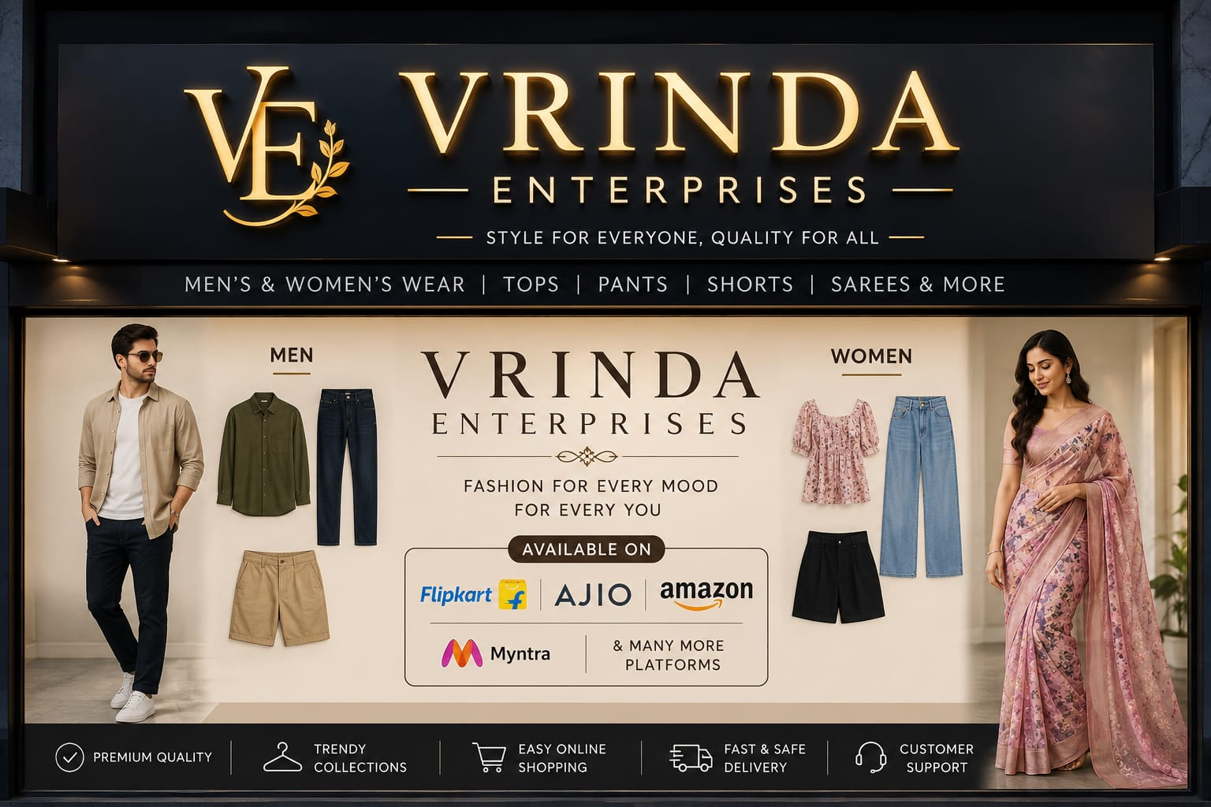

Prepared by:
Harsh Dev Singh
Data Analyst
Date: August 25, 2026

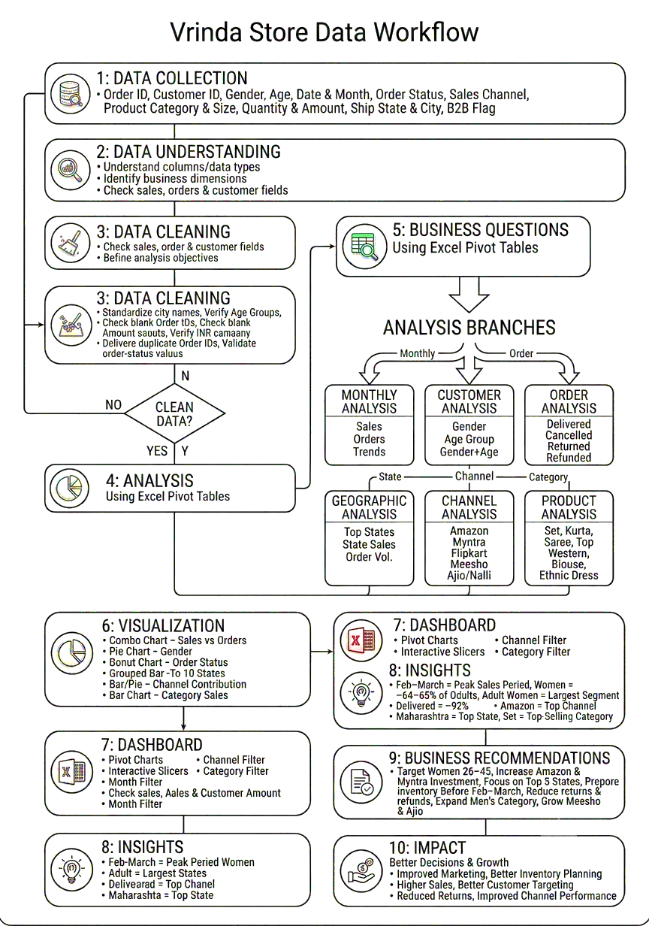

1. Executive Summary

Vrinda Store is an Indian fashion retail brand selling across multiple e-commerce platforms including Amazon, Flipkart, Myntra, Meesho, Ajio, and Nalli. This report presents a comprehensive analysis of the store's order and sales data for the financial year 2022, covering over 31,000 transactions across 20+ Indian states.

The objective of this analysis was to understand customer purchasing behavior, identify top-performing channels and product categories, examine seasonal trends, and provide actionable recommendations to grow sales in the upcoming year.

Total Orders Analysed | ~31,000+
Sales Channels Covered | 8 Platforms (Amazon, Flipkart, Myntra, Meesho, Ajio, Nalli, Others)
Product Categories | Kurta, Set, Saree, Top, Western Dress, Blouse, Ethnic Dress
States Covered | 20+ Indian States
Primary Customer Segment | Adult Women (Age 26–45)
Top Performing Channel | Amazon
Overall Delivery Success Rate | ~92%

2. Objective

Vrinda Store wanted to create an annual sales report for 2022 to help the business understand their customers better and strategise for higher sales in 2023. The analysis was designed to answer the following business questions:

- Q1: Compare total sales and number of orders using a single combined chart
- Q2: Which month recorded the highest sales and order volume?
- Q3: Who purchases more — men or women?
- Q4: What are the different order statuses and their distribution?
- Q5: Which are the top 10 states contributing to sales?
- Q6: What is the relationship between age group and gender based on number of orders?
- Q7: Which sales channel contributes the most to revenue?
- Q8: Which product category generates the highest sales?

3. Data Description & Methodology

3.1 Dataset Overview
The dataset used for this analysis is the Vrinda Store transaction-level sales data for FY 2022, stored in Microsoft Excel. It contains one row per order line item with the following fields:

- Order ID: Unique identifier for each transaction
- Customer ID: Unique customer reference
- Gender: Men / Women
- Age & Age Group: Numerical age and grouped buckets (Teenager, Adult, Senior)
- Date & Month: Order date and month name
- Order Status: Delivered, Cancelled, Returned, Refunded
- Sales Channel: Amazon, Flipkart, Myntra, Meesho, Ajio, Nalli, Others
- Category: Kurta, Set, Saree, Top, Western Dress, Blouse, Ethnic Dress
- Size & Quantity: Product size (XS to 6XL) and units ordered
- Amount (INR): Order value in Indian Rupees
- Ship State & City: Delivery location across India
- B2B Flag: Whether the order is a business-to-business transaction

3.2 Tools Used
- Microsoft Excel: Primary tool for data cleaning, pivot table analysis, and dashboard creation
- Pivot Tables: Used to aggregate data by month, gender, channel, state, and category
- Pivot Charts: Bar, pie, and combo charts created from pivot tables
- Slicers: Interactive filters added to the dashboard for month, channel, and category

3.3 Data Cleaning Steps Performed
- Standardised inconsistent city name casing (e.g., "kolkata" → "KOLKATA", "new Delhi" → "NEW DELHI")
- Verified and corrected the Age Group column labels (Teenager, Adult, Senior)
- Checked for blank/null Order IDs and Amount fields
- Confirmed currency consistency — all transactions in INR
- Removed or flagged duplicate Order IDs where applicable

4. Key Findings & Analysis

4.1 Monthly Sales & Orders Trend
A combo chart was created to compare total sales amount (INR) and total number of orders per month on a single axis. This allowed visual comparison of revenue and volume trends throughout the year.

Monthly Trend — Key Findings
1. March and February recorded the highest combined sales and order volumes, making Q1 the peak season for Vrinda Store.
2. Sales showed a gradual decline from April onward through the second half of the year.
3. December data is present in the dataset but represents a smaller portion, suggesting year-end orders.
4. The sales and order trend moved in sync — months with more orders also had proportionally higher revenue, indicating a stable average order value across the year.

4.2 Gender-Based Purchase Analysis
Orders were segmented by gender to understand the primary buyer demographic.

Gender Analysis — Key Findings
1. Women accounted for approximately 64–65% of total orders, making them the dominant customer segment.
2. Men contributed around 35–36% of orders — a significant but secondary segment.
3. Women's categories (Kurta, Set, Saree, Top) dominated the product mix, consistent with the gender skew.
4. Marketing and inventory planning should continue to priorities women's fashion while exploring growth opportunities in men's categories.

4.3 Order Status Distribution
All orders were categorized into four statuses: Delivered, Cancelled, Returned, and Refunded.

Order Status — Key Findings
1. Delivered orders accounted for approximately 92% of all transactions — a strong fulfilment rate.
2. Returned and Refunded orders together constitute around 5–6% of total orders, indicating manageable post-delivery issues.
3. Cancelled orders were a small fraction (~2–3%), suggesting customers generally follow through on purchases.
4. High delivery success rate reflects well on logistics partnerships across Amazon, Flipkart, and Myntra.

4.4 Top 10 States by Sales Contribution
Geographic sales distribution was analysed to identify which Indian states generated the most revenue.

Top States — Key Findings
1. Maharashtra ranked as the top contributing state by both order volume and sales value.
2. Karnataka and Uttar Pradesh followed closely, forming the top 3 states.
3. Tamil Nadu, Telangana, and Delhi were strong contributors in positions 4–6.
4. West Bengal, Rajasthan, Andhra Pradesh, and Gujarat rounded out the top 10.
5. These 10 states collectively account for the majority of total sales, indicating a strong metro and tier-1 city base.

4.5 Age Group vs Gender Analysis
Orders were cross-analysed by age group (Teenager: 13–25, Adult: 26–45, Senior: 46+) and gender to understand the most active demographic.

Age & Gender Analysis — Key Findings
1. Adult women (age 26–45) are the single largest purchasing group, contributing the most orders across all segments.
2. Adult men also showed strong purchasing behavior, being the second-largest group.
3. Teenage women are an emerging segment with notable order volumes — a growth opportunity.
4. Senior customers (46+) of both genders showed meaningful participation, especially women, suggesting the product range appeals across age groups.

4.6 Channel-Wise Sales Contribution
Eight channels were analysed to determine which platform drives the most business for Vrinda Store.

Channel Analysis — Key Findings
1. Amazon is the top-performing channel, contributing the largest share of orders and revenue.
2. Myntra and Flipkart are strong second and third platforms respectively.
3. Meesho and Ajio show significant volumes, reflecting the rise of social and fashion-specific commerce.
4. Nalli caters to a niche saree-focused audience and contributes a smaller but loyal customer base.
5. "Others" channel (direct, offline, or unlisted platforms) forms a minor but consistent portion.
6. Recommendation: Priorities ad spend and inventory allocation on Amazon and Myntra for maximum ROI.

4.7 Top-Selling Product Categories
Product categories were ranked by total order volume and total sales value.

Category Analysis — Key Findings
1. Set (co-ordinated outfit sets) is the highest-selling category by order volume.
2. Kurta is the second most popular category, with broad appeal across age groups and states.
3. Saree contributes strong average order values, especially on Nalli and Amazon.
4. Western Dress and Top are growing categories, particularly popular among teenage and adult women.
5. Blouse and Ethnic Dress are niche categories but serve a loyal audience.
6. Seasonal stocking should be maximized for Sets and Kurtas ahead of the March peak season.

5. Excel Dashboard Overview

An interactive Excel dashboard was created as the visual output of this analysis. The dashboard is built on the "REPORT 2022" sheet and integrates multiple pivot charts with connected slicers for dynamic filtering.

5.1 Dashboard Components
- Chart 1 – Sales vs Orders (Combo Chart): Bar chart for order count overlaid with a line chart for total sales amount by month
- Chart 2 – Gender Split (Pie Chart): Percentage breakdown of orders by Men vs Women
- Chart 3 – Order Status (Pie/Donut Chart): Distribution of Delivered, Returned, Cancelled, and Refunded orders
- Chart 4 – Top 10 States (Bar Chart): Horizontal bar chart ranking states by sales contribution
- Chart 5 – Age vs Gender (Grouped Bar Chart): Order count grouped by age group with gender as colour segments
- Chart 6 – Channel Contribution (Bar/Pie Chart): Sales share by each e-commerce platform
- Chart 7 – Category Sales (Bar Chart): Order volume and revenue by product category

5.2 Slicers / Filters
- Month slicer — filter all charts by a specific month
- Channel slicer — isolate performance of a specific platform
- Category slicer — drill into a product category across all other dimensions

6. Conclusion

The Vrinda Store FY 2022 analysis reveals a business with a strong, loyal female customer base, exceptional delivery performance, and significant geographic concentration in western and southern India. The data clearly points to actionable strategies for improving sales in 2023.

6.1 Strategic Recommendations for 2023

- 1. Focus on Women Aged 26–45: This segment drives the majority of revenue. Personalized marketing campaigns, loyalty offers, and product launches for adult women. Seasonal promotions in Feb–March should be planned 6–8 weeks in advance.

- 2. Double Down on Amazon & Myntra: These two platforms deliver the highest order volumes. Invest in sponsored listings, better product imagery, and faster fulfilment on these channels. Explore Myntra's fashion week sale events for seasonal spikes.

- 3. Expand in Top 5 States: Maharashtra, Karnataka, UP, Tamil Nadu, and Telangana are the primary revenue drivers. Consider state-specific promotions, regional influencer tie-ups, and faster delivery SLAs in these zones.

- 4. Maximize Feb–March Sales Window: The Q1 peak must be fully capitalized on. Launch new collections in January, run early-bird offers in February, and plan maximum stock availability for March.

- 5. Reduce Returns & Refunds: Though return rates are low (~5–6%), even small improvements in size guide accuracy and product photography can reduce returns further and protect margins.

- 6. Grow the Men's Category: Men represent 35% of customers — an underserved segment with growth potential. Introducing curated men's collections on Myntra and Amazon could unlock a new revenue stream.

- 7. Invest in Meesho & Ajio: These platforms are growing rapidly. Early investment in presence here can build market share before competition intensifies.

Priority Area | Action
Peak Season Prep | Stock up and launch campaigns in January for Feb–March peak
Top Channel Investment | Increase ad budget on Amazon and Myntra
Customer Targeting | Focus on women aged 26–45 in top 5 states
Category Expansion | Launch men's collections to capture 35% male base
Return Rate Reduction | Improve size guides and product descriptions
Emerging Platform Growth | Build presence on Meesho and Ajio early

7. About the Analyst

This analysis was independently conducted as a portfolio project to demonstrate end-to-end data analysis skills — from raw data understanding and cleaning, through pivot-based aggregation, to dashboard creation and insight generation.

- Analyst: Harsh Dev Singh
- Skill Demonstrated: Excel Data Analysis, Pivot Tables, Dashboard Design, Business Insight Generation
- Tool Used: Microsoft Excel (Pivot Tables, Charts, Slicers)
- Dataset: Vrinda Store E-commerce Sales Data, FY 2022
- Report Date: August 25, 2026

***End of The Report***

